| Name: | Advait Dhakad |
| --- | --- |
| Roll No: | 1510 |
| Title of Program: | Stacks & Queues: Stack Application |
| Objective: | 1. Parenthesis Balancing 2. Postfix Evaluation |

**1) Parenthesis Balancing - Stack Application**

**CODE:**

public class ParBal {

public static void main(String[] args) {

String expression = "((a+b))+(c+d)";

if (isBalanced(expression)) {

System.out.println("Parenthesis are balanced");

} else {

System.out.println("Parenthesis are not balanced !!");

}

}

public static boolean isBalanced(String ex) {

char[] stack = new char[ex.length()];

int tos = -1;

for (int i = 0; i < ex.length(); i++) {

char ch = ex.charAt(i);

if (ch == '(') {

tos++;

stack[tos] = ch;

} else if (ch == ')') // if closing parenthesis then pop

{

if (tos == -1) // No matching parenthesis

{

return false;

}

tos--; // pop from the stack

}

} // end of for

if (tos == -1) {

return true;

} else {

return false;

}

// or above can be written as

// return tos==-1;

}// end of isBalanced

}// end of ParBal

**OUTPUT:**

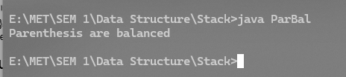

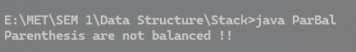

**2) Postfix Evaluation**

import java.util.*;

class PostEval {

public static void main(String[] args) {

String expr = "23*5+62/-";

int result = evaluate(expr);

System.out.println("Result of postfix evaluation: " +

result);

}

public static int evaluate(String ex) {

int[] stack = new int[ex.length()];

int tos = -1;

for (int i = 0; i < ex.length(); i++) {

char ch = ex.charAt(i);

if (Character.isDigit(ch)) // if ch is a digit -

{

tos++;

stack[tos] = ch - '0';

} else if (ch == '+' || ch == '-' || ch == '*' || ch == '/') // if ch is operator

{

int op2 = stack[tos--]; // pop the 2nd

int op1 = stack[tos--]; // pop the 1st

int res = 0;

switch (ch) {

case '+':

res = op1 + op2;

break;

case '-':

res = op1 - op2;

break;

case '*':

res = op1 * op2;

break;

case '/':

res = op1 / op2;

break;

} // -end of switch-case

// Push the result back on the stack

tos++;

stack[tos] = res;

}

} // -end of for loop

// Final result at tos

return stack[tos];

} // -end of evaluate()

} // -end of PostEval class

**OUTPUT**

